**Week 3 Assignment**

Denzil Stavinoha

CST 499

Joseph Rangitsch

August 12, 2024

**Week 3 Assignment**

* Discuss the MySQL database functions that you used and the steps you took to create the database connection custom class.

Setting up the database was simple. I opened XAMPP, started Apache and MySQL, clicked the admin button, clicked new to create a new database, titled the database ‘student’, and clicked create. This takes you automatically to the tables page, where I typed in 8 for the number of columns and tblUser for the table name, clicked create, named the columns, set their types, then clicked save, and the table was created.

I learned in our previous classes that the variables for the servername, username, etc., needed to be defined outside of the class. I used the $this-> keyword for the function to be called outside of the class. W3 was a big help for this. I found this under PHP Classes/Objects (W3Schools, 2024). The functions executeSelectQuery and executeQuery both functions to create the query and write to the database. They both use if statements to return errors or perform the desired tasks of either updating, editing, or deleting data for the executeQuery and returning data for the executeSelectQuery.

* Explain the steps taken to create the registration page and save the user information in the database.

Many of the steps taken to create the registration page were very similar to the website created in previous classes. The class and functions were a big step in getting the rest of the program to work and actually deposit the data into the table. Once the classes were created, the first time I tried to call them, it worked flawlessly. The <form> in HTML was my start to take the information in and use the method post to send the data. I then used the universals of $_SERVER and $_POST to look for the request method of post and assigned the data to the correct table variables, and it worked great and as expected. I also worked a little bit ahead and went ahead and developed the registration page to display all user information, as well as created a logout page.

* Provide screenshots of all developed pages, databases, tables, layout, and source code.

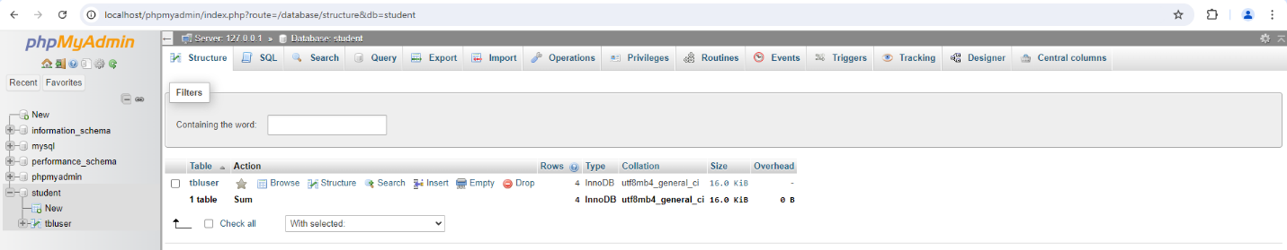

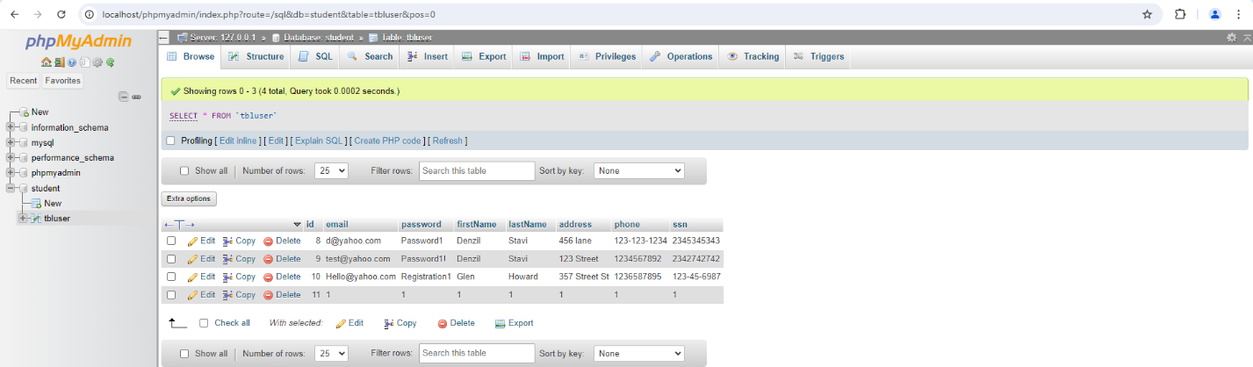

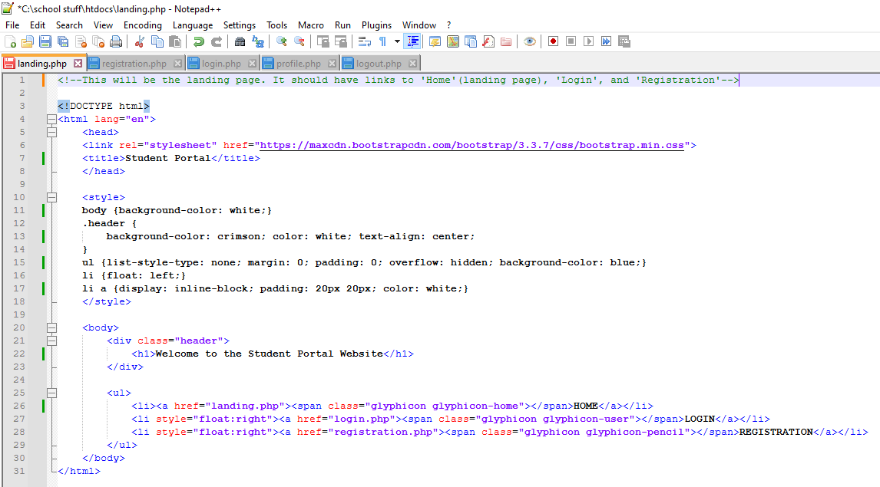

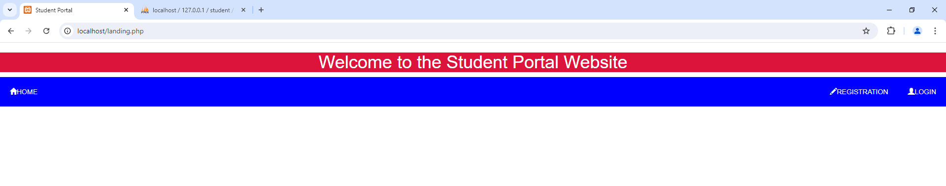

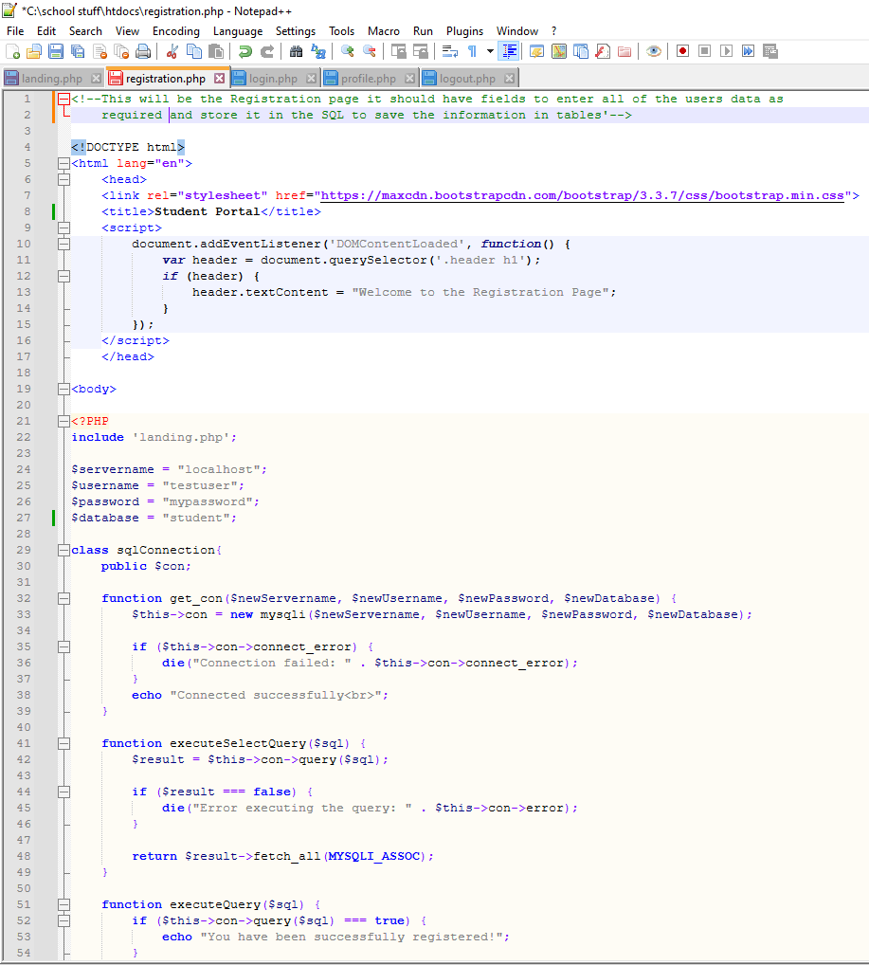

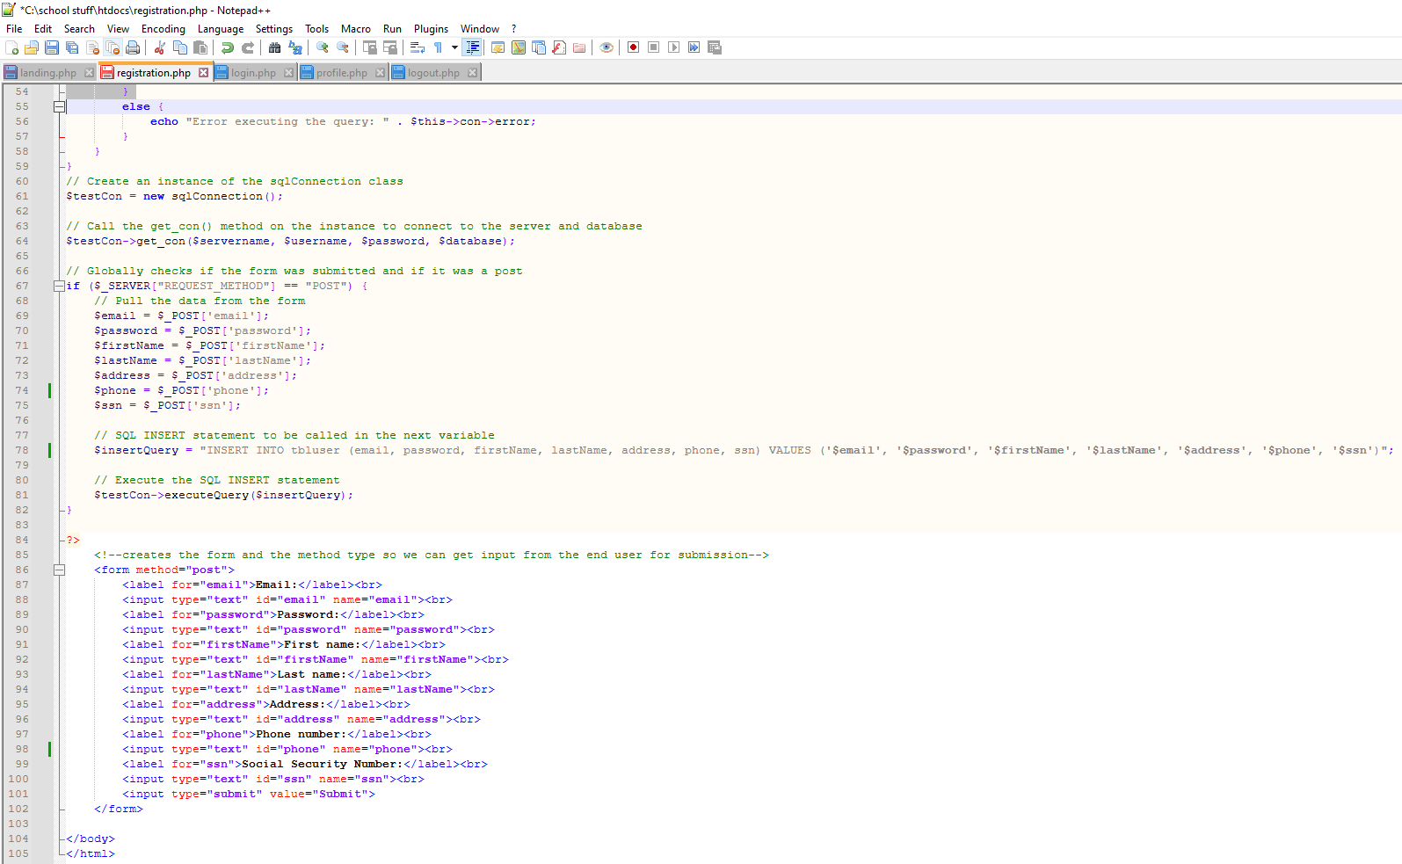

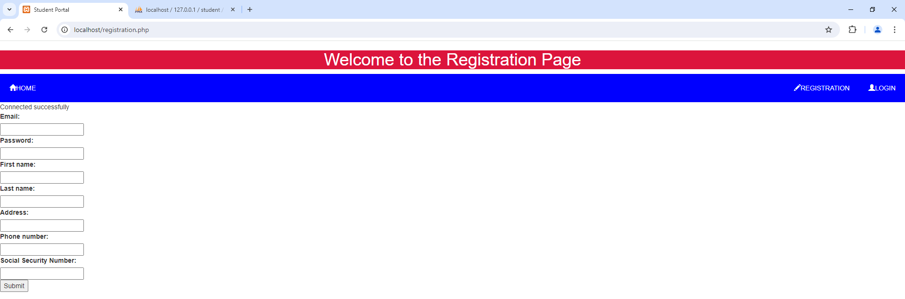

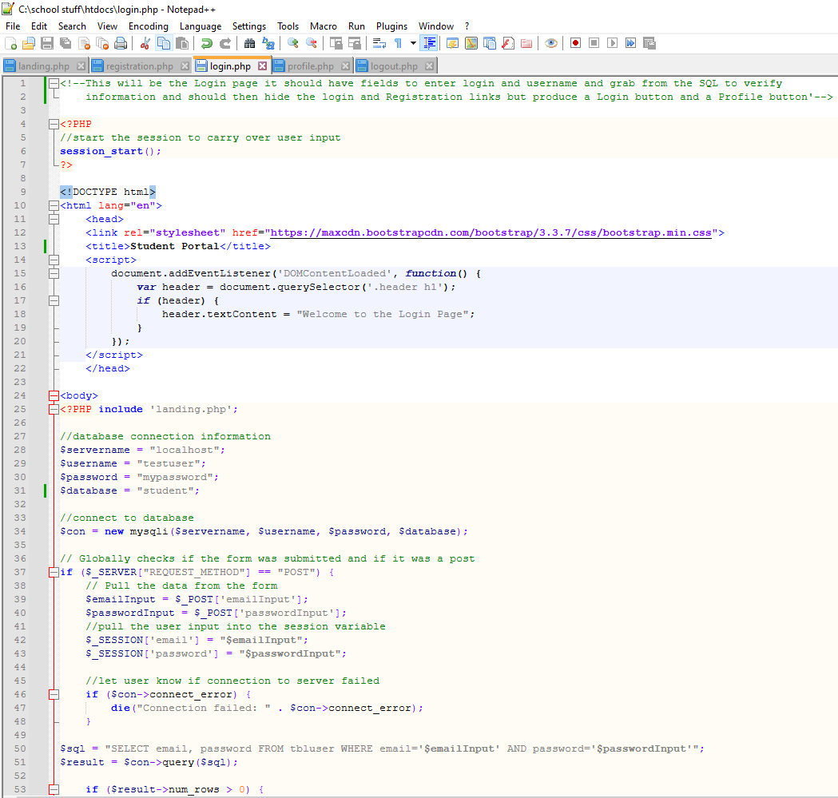

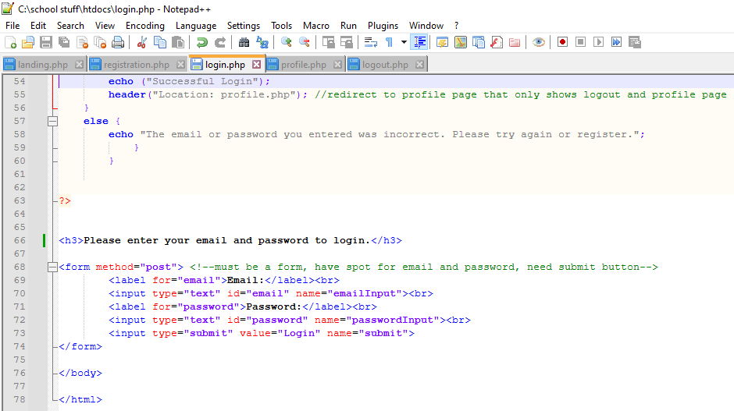

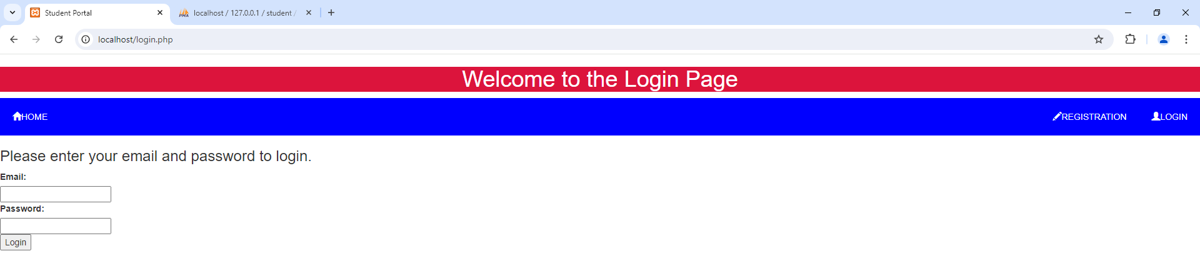

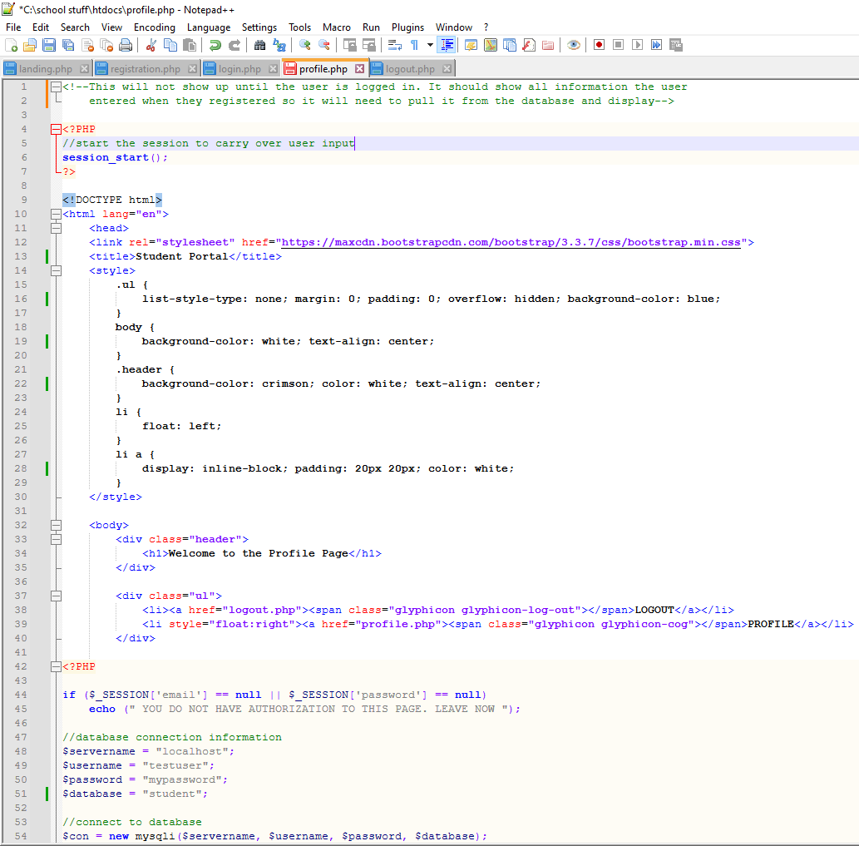

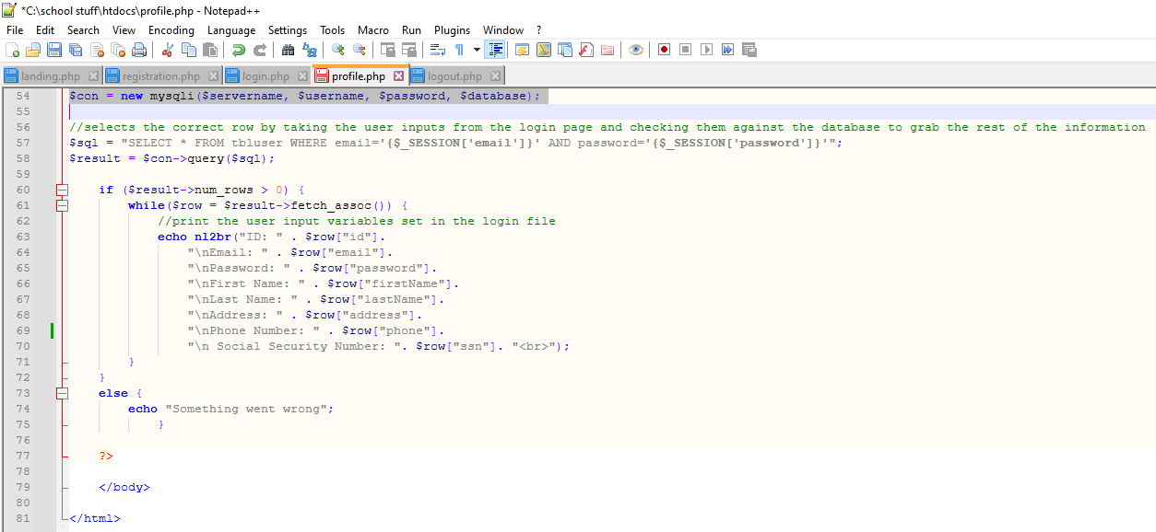

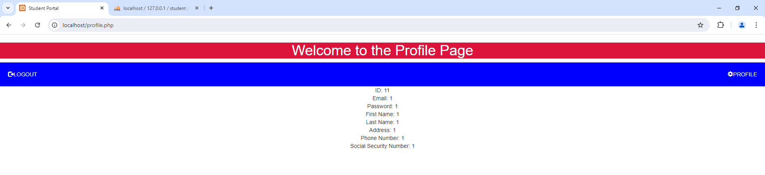

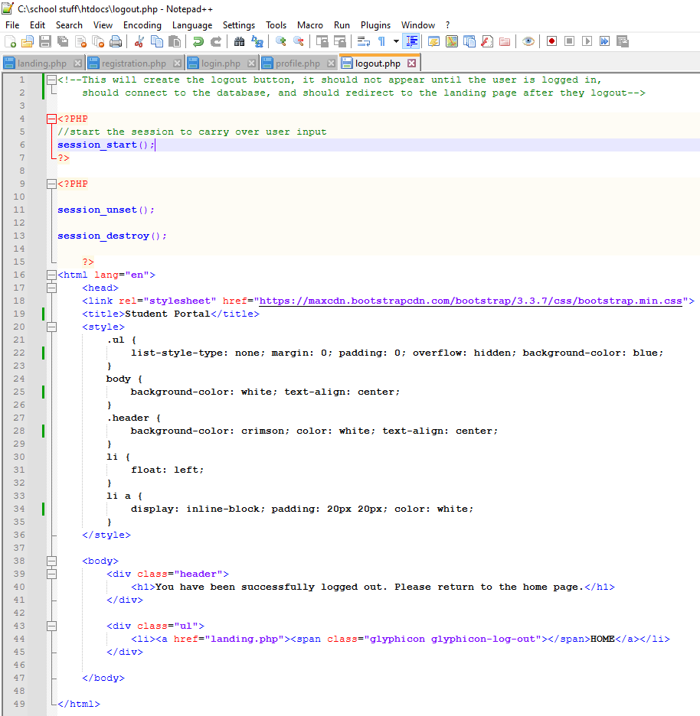

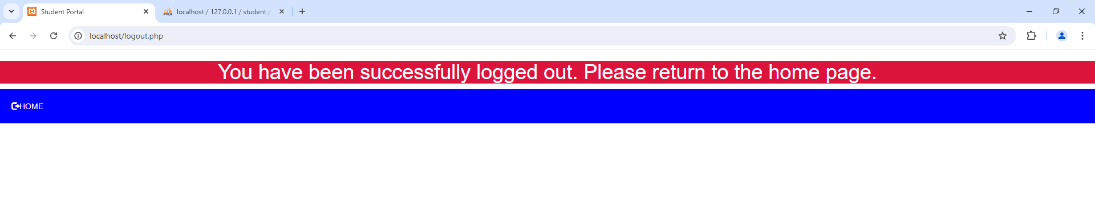

**References**

Ravikiran, A. S. (July 10, 2024). How to Run a PHP File Using XAMPP: A Step By Step Guide. Simplilearn. <https://www.simplilearn.com/tutorials/php-tutorial/php-using-xampp>

W3Schools. (n.d.). Learn to Code. Retrieved August 10, 2024 from <https://www.w3schools.com/php/php_oop_classes_objects.asp>